Final Report
Tyler Palam
Platform Jumper Game inspired by Geometry Dash
Introduction
For my final project, I created a Geometry Dash-style platformer using C++ and SFML 2.6.2. The game is a side-scrolling platformer where the player controls a square that automatically moves forward through a custom-built level. The player must jump over spikes, avoid rotating saw blades, use speed-changing power-ups, and reach the finish line. I chose this game because my younger brother loves this game and I thought it would be fun to recreate it.
The main theme of the project is recreating the basic gameplay feel of Geometry Dash while focusing on object-oriented programming concepts from ECE 205. The game includes a player-created map loaded from a JSON file, a scrolling camera, collision detection, power-ups, obstacles, game states, sound effects, background music, and a parallax background.
A major goal of the project was to organize the game using classes instead of putting everything into one large main.cpp file to maintain order with encapsulation. The final structure separates responsibilities into classes such as Game, Player, Level, Platform, Obstacle, Spike, SawBlade, PowerUp, etc. Later on, I applied design patterns to let other classes extend on other base classes, demonstrating the Open-Closed principle.

Gameplay and Workflow
The game begins on a start screen. The player presses Space to begin. Once the game starts, the square automatically moves to the right. The player can press Space to jump. The goal is to survive the level and reach the finish line.
The gameplay loop works like this:
- The player starts at the beginning of the level.
- The camera follows the player as the player moves right.
- The player jumps over spikes and saw blades.
- If the player touches a dangerous obstacle, the player dies.
- The player can press R to restart.
- If the player reaches the finish line, the game enters the complete state.
- The player can pause and resume using P.
The level itself is loaded from a JSON file. This allows platforms, spikes, saw blades, power-ups, and the finish line to be edited without hard-coding every object directly into Game.cpp. A factory then creates the objects using the data. This is useful because the map is player-created. In reality, it is quite tedious to hand code all obstacles into the JSON file, so I intend to implement a level editor for future updates.
For functionality, the game compiles and runs as intended as of Friday August 14.
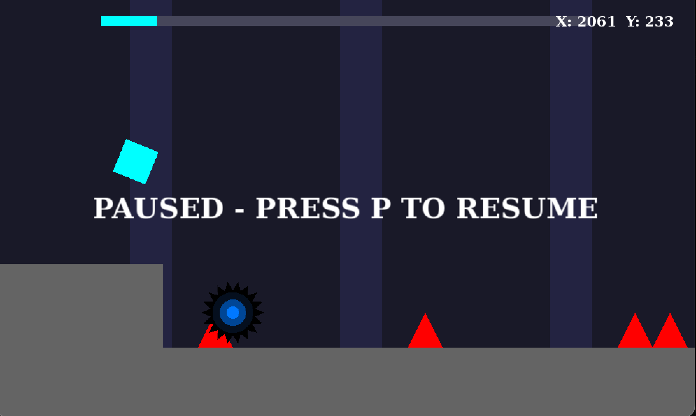
Pause is a game state, triggered when the user presses P.
void Game::run() {
while (window.isOpen()) {
float deltaTime =
clock.restart().asSeconds();

processEvents();

update(deltaTime);

render();
}
}
The main game loop. This loop separates the game into three main phases: input, update, and rendering.
Classes and Relationships
The project uses multiple classes to separate responsibilities.
The Game class controls the main game loop. It owns the SFML window, camera, player, level, finish line, background, UI text, audio (planned), and game state.
class Game {
private:
sf::RenderWindow window;
sf::View camera;
sf::Clock clock;

Player player;
Level level;
FinishLine finishLine;

GameState state; //and so on….

public:
Game();

void run();
};

#endif

Game acts as the main coordinator. It does not directly define how every object works. Instead, it calls functions such as
player.update(deltaTime);
obstacle->update(deltaTime);
powerUp->apply(player);
platform.draw(window);

The Player class controls the square character. It stores the player’s shape, speed, gravity, jump velocity, alive status, and whether the player is on the ground.
class Player {
private:
sf::RectangleShape box;

float horizontalSpeed;
float normalSpeed;
float verticalVelocity;
float gravity;
float jumpVelocity;

bool onGround;
bool alive;

public:
void update(float deltaTime);
bool jump();
void die();
void reset();

void setHorizontalSpeed(float speed);
void resetHorizontalSpeed();
};

Movement is not dependent on frame rate:
verticalVelocity += gravity * deltaTime;
box.move(
horizontalSpeed * deltaTime,
verticalVelocity * deltaTime
);

The Level class loads the map from level.json. It stores platforms, obstacles, and power-ups.
The Platform class represents solid ground or raised platforms. It stores an sf::RectangleShape, draws itself, and returns collision bounds.

Abstract base class Obstacle and further derived classes Spike and SawBlade:
Obstacle is an abstract base class. It defines the common interface for dangerous objects.
class Obstacle {
public:
virtual void update(float deltaTime) = 0;
virtual void draw(sf::RenderWindow& window) const = 0;
virtual sf::FloatRect getBounds() const = 0;

virtual ~Obstacle() = default;
};

Spike inherits from Obstacle:
class Spike : public Obstacle {
private:
sf::ConvexShape shape;

public:
void update(float deltaTime) override;
void draw(sf::RenderWindow& window) const override;
sf::FloatRect getBounds() const override;
};

Sawblade also inherites from Obstacle the same way. By using inheritance, Game can treat spikes and saw blades the same way:
for (const auto& obstacle : level.getObstacles()) {
obstacle->update(deltaTime);
}

PowerUp, SpeedBoost, and SlowDown:
PowerUp is another abstract base class. It defines a common interface for objects that affect the player. SpeedBoost increases the player’s speed, and SlowDown returns the player to normal speed. Power ups are implemented and inherited from the base class, like how spike and sawblade inherited from obstacle.

Inheritance and Composition
The project uses both inheritance and composition. As shown above, inheritance is used with the Obstacle and PowerUp systems.
Composition is also used heavily. The Game class is composed of many objects:
Player player;
Level level;
FinishLine finishLine;
Background background;

The Level class is composed of platforms, obstacles, and power-ups:
std::vector<Platform> platforms;
std::vector<std::unique_ptr<Obstacle>> obstacles;
std::vector<std::unique_ptr<PowerUp>> powerUps;

Design Patterns
The factory pattern is used in the ObjectFactory class. The ObjectFactory class is responsible for creating game objects based on data loaded from the JSON file.
For example, Level::loadFromFile() reads data from the JSON file:
float x =
spikeData["x"];

float groundTop =
spikeData["groundTop"];

Then it uses the factory to create an obstacle:
obstacles.push_back(
ObjectFactory::createSpike(
x,
groundTop
)
);

For saw blades, the factory creates the correct obstacle subclass:
obstacles.push_back(
ObjectFactory::createSawBlade(
x,
y,
radius,
style
)
);

The reason this pattern is useful is that it separates object creation from level loading. Level reads the data, but ObjectFactory decides how to construct the objects.

Lessons Learned
I learned a lot about c++ and OOP over the course of this project. I also learned the importance of design patterns in creating a complex game. I learned much about inheritance, and factory design pattern. I guess the game state manager would also count as a Singleton, since only one state instance is allowed at a time. However, if I were to do things differently, I would have also used strategy to control player movement behavior as it touches power ups and enters portals to become a Galactica type platform game. I would also create a level editing menu so players can create their own levels in-game, thus editing the JSON data, rather than me editing the JSON data by hand.
Overall, I learned much doing this project. It taught me the importance of OOP, the different techniques to make many different parts of a program to work efficiently, and the insight needed to actively create a complex program and understand how each part of the code works. I plan on refining my game and making it a full-fledged Geometry Dash copy (not exact, but similar with my own additions) after implanting the rest of the menu system, level editing system, game modes accessed through portals, and other UI/physics tweaks.

Peer Reviews
Brandon’s 3D Shooter Game:
Brandon’s 3D shooter game was fun and impressive. I liked his use of the Singleton pattern for the score manager, which provided a centralized way to manage the player’s score throughout the game. I also found his use of shaders in SFML interesting because it demonstrated another capability of SFML beyond the features I used in my own project. Overall, the game looked fun to play and is something I would play myself.
Nicco’s Galaga Game:
Nicco’s Galaga game was very impressive and demonstrated good encapsulation throughout the project. I especially liked his use of multiple design patterns, including the Object Pool pattern, Singleton pattern, and Strategy pattern for boss movement. The Strategy implementation was a good example of how different behaviors can be separated and changed during gameplay. His introduction was also very creative, and the use of audio was a nice touch even though it was not working properly during the presentation.
Mengsong’s Fish Game:
Mengsong’s fishing game had a very interesting concept involving a boat going fishing. I especially liked the visual presentation of the game, and the pictures and graphics looked very nice.
Faith’s Jungle Jumper:
Faith’s Jungle Jumper had a very polished presentation with nice aesthetics. I thought the project demonstrated very good use of inheritance and design patterns, and it was clear that these concepts were incorporated into the structure of the game. The game itself also looked very nice and polished. It looked like the type of game I would play on my downtime.

